ME-Seal-Mesopotamia-Kings at Altar of Sun

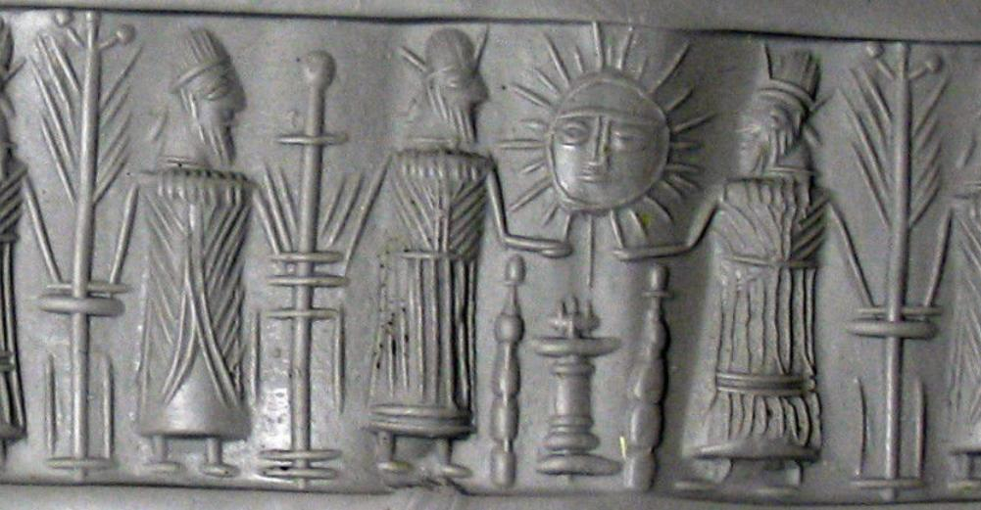

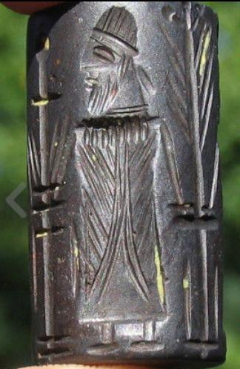 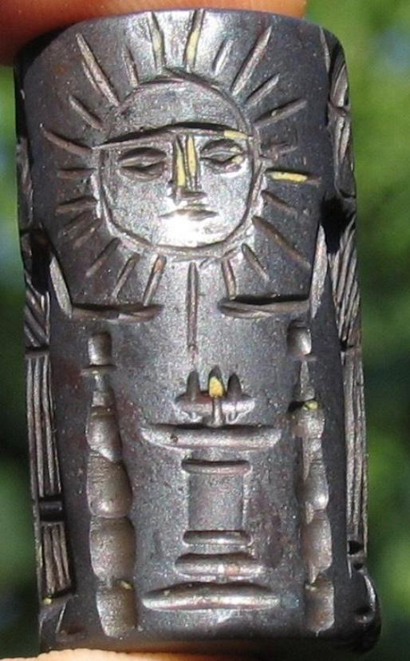 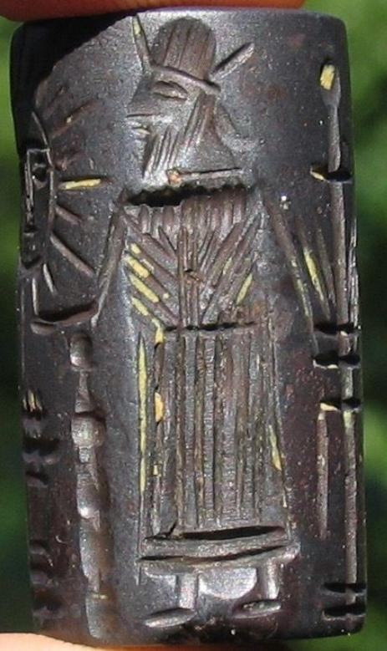

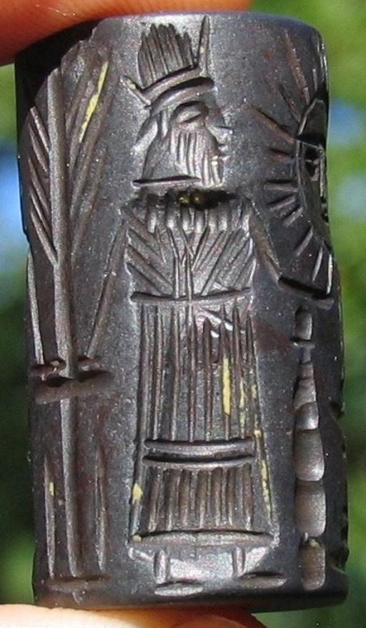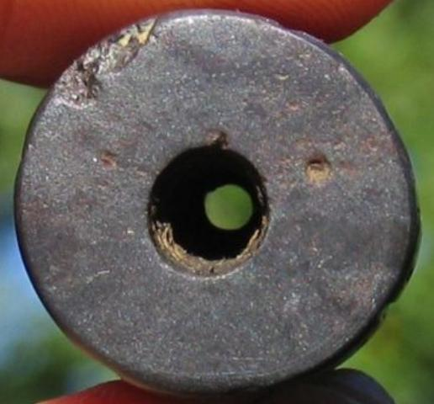

Classic scene of kings at alter with the sun.

Formal Label: Mesopotamian seal with classic scene of kings at alter with the sun.

Accession Number:

Date or Time Horizon: 5000-3000 BCE

Geographical Area: Mesopotamia

Cultural Affiliation:

Medium: Hematite

Dimensions: 37 mm

Weight:

Provenance: Private collection, Asheville, North Carolina,

Sold by [estateconsignor](http://myworld.ebay.com/estateconsignor) ( [386](http://feedback.ebay.com/ws/eBayISAPI.dll?ViewFeedback&userid=estateconsignor) )

Estimated delivery Thursday, Dec 15, 2016 - Monday, Dec 19, 2016

#### [MAGNIFICENT RARE ANCIENT NEAR EASTERN CYLINDER SEAL, AGATE, 3000 BC](http://www.ebay.com/itm/361841366480)

|  |  |
| --- | --- |
| Item price | $457.00 |
| Quantity | 1 |
| Item number | 361841366480 |
| Shipping service | USPS Priority Mail |

#### [3000-5000BC MESOPOTAMIAN CYLINDER SEAL HEMATITE, ANCIENT](http://www.ebay.com/itm/361841366481)

|  |  |
| --- | --- |
| Item price | $297.00 |
| Quantity | 1 |
| Item number | 361841366481 |
| Shipping service | USPS Priority Mail |

#### [RARE AMBER 3000-5000BC MESOPOTAMIAN CYLINDER SEAL ANCIENT](http://www.ebay.com/itm/361841366484)

|  |  |
| --- | --- |
| Item price | $316.90 |
| Quantity | 1 |
| Item number | 361841366484 |
| Shipping service | USPS Priority Mail |